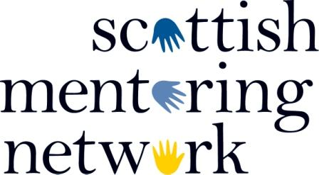

Dear Member

Notice is hereby given that the Annual General Meeting of Scottish Mentoring Network will take place on Tuesday 6th November 2018 at 1.00pm, at St Paul’s & St George’s Church, 10 Broughton Street, Edinburgh, EH1 3RH. One representative of each eligible member organisation is requested to attend this AGM.

The agenda for the meeting is a follows.

- Report on the operations during Financial Year to 31st March 2018
- Report on the Annual Accounts for Financial Year to 31st March 2018
- Approval of the updated Articles of Association
- Election of Directors
- Any Other Competent Business

By order of the Board
11th October 2018

All relevant documents for Approval of the updated Articles of Association are attached.

If any member has any questions in connection with the AGM please contact Iain Forbes at Iain@scottishmentoringnetwork.co.uk

A Charitable Company Limited by Guarantee, registered in Scotland No. 282564, Charity No. SC037677

