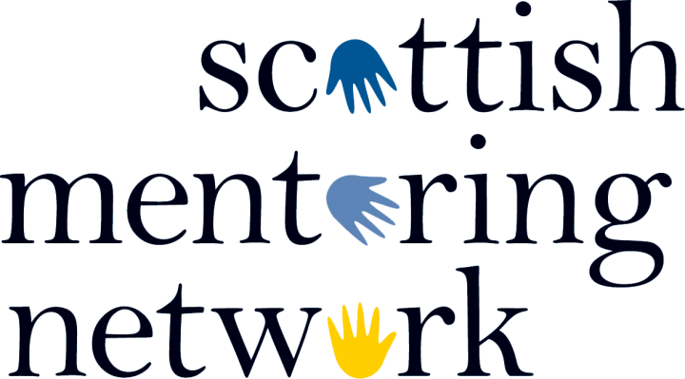

BOARD DIRECTORS’/TRUSTEES’ ROLE DESCRIPTION

Register No. | 10GB
Approved by Board | October 2018
To be Reviewed | October 2021

- Introduction
  - There are two categories of Board Director within Scottish Mentoring Network:

    - “General Member Director” means a director drawn from the General Membership of SMN);
    - “Co-opted Director” means a (non-member) director appointed by the directors
  - The Board of Directors of SMN is made up of up to 12 individuals, of which up to 7 are General Member Directors and no more than 5 are Co-opted Directors.
    - A General Member Director is an individual who is a member of SMN or an individual who has been nominated by an organisation that is a member of SMN.
    - A Co-opted Director is a non-member who is invited to join the Board, often because the individual brings a particular skill or expertise to the Board.
- Specific Duties and Responsibilities of all Board Directors (also known as Trustees)

  - There is a core set of duties and responsibilities that apply to all Board Directors/Trustees:
    - To ensure that the organisation complies with its Articles of Association, charity law, company law and any other relevant legislation or regulations, direction, requirement, notice or duty imposed by such legislation;
    - To ensure that the organisation pursues its objects;
    - To ensure that the organisation applies its resources exclusively in pursuance of its objects. In other words the organisation must not spend money on activities which are not in support or furtherance of its own purposes, no matter how worthwhile or charitable those activities are;
    - To contribute actively to the Board of Directors’ role in giving strategic direction to the organisation, setting overall policy, defining goals and setting targets and evaluating performance against agreed targets;
    - To comply with the legal duties and responsibilities of a Company Director and a charity Director;
    - To safeguard the good name and values of the organisation, to comply with the “Board Code of Conduct” document published by the Office of the Scottish Charity Regulator and to adhere to the policy requirements of the organisation as set out in this document and in other policy and procedure manuals;
    - To ensure the effective and efficient administration of the organisation;
    - To ensure the financial stability of the organisation;
    - To appoint the Chief Executive of the organisation and monitor his/her performance;
    - To sit on appointment, appraisal, recruitment and disciplinary panels and sub-committees as required;
    - Undertaking specific assignments at the request of the Chair.
  - In addition to the above specific duties, each Board Director should use any specific skills, knowledge or experience they have to help the Board of Directors reach sound decisions. This will involve scrutinising Board papers, leading discussions, focusing on key issues, providing advice and guidance on new initiatives or other issues in which the Board Director has particular knowledge or experience. Also, where Board Directors are appointed by the Board to be part of, any committee or working group, they should contribute actively to that committee or group, including:
    - ensuring that the committee or group adheres to its remit and that it does not depart from the policies and strategy of the Board;
    - preparing properly for meetings; and
    - Undertaking any tasks requested by the group.
  - Scottish Mentoring Network is also a charity. The Board of Directors is also responsible for ensuring that it is compliant with the requirements of a charity and charity law. As such the board of directors must also:
    - Act in the interests of the charity
- Directors must operate in a manner consistent with the charity's purpose
- Directors must act with care and diligence
- Directors must manage any conflict of interest between the charity and any person or organisation who appoints trustees
    - Comply with the 2005 Act (specific duties)
- Charity details on the Scottish Charity Register
- Reporting to OSCR: making changes to your charity
- Financial records and reporting
- Fundraising
- Providing information to the public.

- Board Director Person Specification

Essential | Desirable
- The ability to think strategically and creatively  - an understanding and acceptance of the legal duties, responsibilities and liabilities of a director  - Understanding of governance in the third sector  - An understanding of strategic financial planning and management  - An understanding of mentoring  - Ability to analyse and critique information  - An ability to work effectively as a member of a team and to take decisions for the good of SMN. | - 3-5 years working at a senior/strategic/leadership level  - Understanding of the policy environment and how it affects the third sector  - Experience in one or some of the following:  - Digital marketing and communications  - Fundraising/submitting and reviewing funding applications  - Strategic planning  - Influencing  - Financial management and/or accounting  - HR
Personal Attributes:
- a commitment to the mission of SMN

- a willingness to devote the necessary time and effort

- integrity

- good, independent judgement

- Minimum time commitment

  - Directors are expected to:
    - Attend an induction session at SMN with the Chair of the Board prior to their first board meeting.
    - Attend all board meetings
- meetings are held six times a year during normal office hours
- meetings alternate between Edinburgh and Glasgow.
- if Directors cannot attend in person, we will make every effort to make meetings accessible by video/telephone
- papers are distributed one week in advance of meetings.
    - Take on additional duties (involvement in working groups, involvement in recruitment and selection of staff, attendance at the National Conference etc.) These are ad-hoc and will be arranged at times suitable to Directors.
  - Directors can claim out of pocket expenses incurred in travelling to meetings and SMN events.

